There is a need to run the One Step Wholesaler EDI in an operator unattended mode. The process will now be available as a phantom. Operations will run the Wholesaler EDI Comms Start, then run the Phantom One Step Start. The phantom will run at its specified times throughout the day. After it has completed its final run for the day, it will automatically log itself off.

If there’s any need to check on the phantom’s activity, a como record is stored in the _PH_ file by warehouse name. Example: if you start a phantom One Step Wholesaler EDI for warehouse 001, the name of the como record would be O_PHANTOM.ONE.STEP001. When the phantom logs itself off at the end of the day, it will change the name of that record, adding *YYMMDD onto the end of the name. Example: if the system date at the time when the phantom logs off is 01/25/03, the como record will be renamed O_PHANTOM.ONE.STEP001*030125.

Initial Maintenance

The new Phantom One-Step Wholesaler EDI processes are on menu 24-1-2-12:

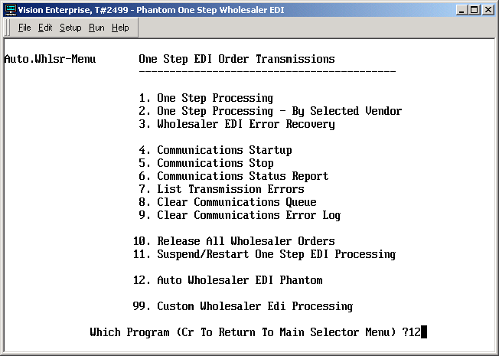

Initial parameter maintenance needs to be setup in menu selection 3:

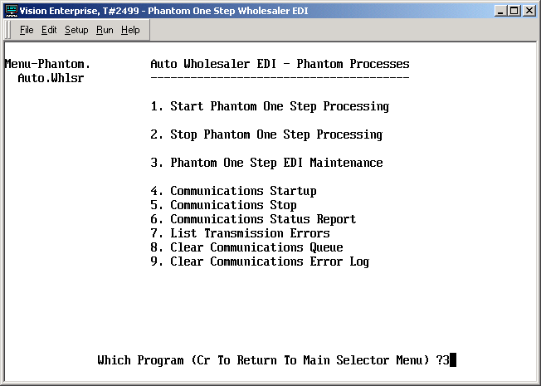

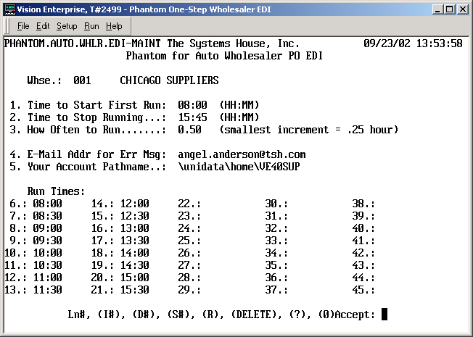

Key – The Key is the Warehouse number that is being set up. This will be validated against the Warehouse file, and the Warehouse name will be displayed.

1. Time to Start First Run – the time in HH:MM military format. Examples: 00:01 for one minute after
midnight, 8:00 for 8 o’clock a.m., 13:00 for 1 o’clock p.m. This is a required field.

2. Time to Stop Running – the time in HH:MM military format. Examples: 16:30 for 4:30 p.m., 17:00
for 5 o’clock p.m.

3. How Often to Run – in quarter hour increments. .25 to run every 15 minutes, .50 to run every 30
minutes, .75 to run every 45 minutes, 1 to run every hour, 1.50 to run every hour-and-a-half, etc.
Required field. This will establish the initial run times for you. From that point, you can either
maintain the Run Times individually, or change the frequency, start time, or end time and
optionally have the program recalculate the Run Times for you.

4. E-Mail Addr for Err Msg – the e-mail address of the person who will resolve any One-Step Wholesaler
EDI errors that may occur during the phantom run. Messages per the errors encountered will be
automatically e-mailed to this address by the phantom processor. This is a required field, up to 40
characters.

5. Your Account Pathname – the pathname of your account. You can get this by typing WHERE at ECL.
Required. Up to 45 characters.

6 – 45. Run Times – You can run the One-Step Wholesaler EDI in phantom mode up to 40 times a day.
No times are required. If you leave a gap between the fields, the program will automatically close
that gap for you. Each time input must be in HH:MM format. It must be later than the time before
it, and earlier than the time that follows it.

Ln#, (I#), (D#), (S#), (R), (DELETE), (?), (0)Accept: -
Ln# allows you to change any of fields 1 through 44
I# allows you to insert before the field number that you specify. Example: I7 will bump the fields
forward, starting by moving the data in field 7 into field 8. If will then put you into input
mode in the newly emptied field 7. This command is only valid for fields 5 through 44.
D# allows you to delete the field number that you specify. This is only valid for fields 5 through
44.
S# allows you to begin stepping through all of the inputs again, starting at the field number that
you specify.
R allows you to restart without saving any of the changes that you had already made.
DELETE allows you to delete the parameter record entirely. This is only recommended if you
want to stop anybody from running One Step Wholesaler EDI in phantom mode.
(?) – is for help instructions.
(0)Accept – saves the record when you have completed maintenance.

The example above shows us selecting the option to run the one step every half hour, and allowing the program to calculate the run times. If you then decide to run it every 3/4 hour, select field 3 and change it to .75. You will be asked the question shown on the next page:

Would you like to recalculate the Run Times? (Y/N) – Y to have the program refigure the run times for you. N if you want to leave it the way it is and make manual modifications.

Following is the result if the input response is Y:

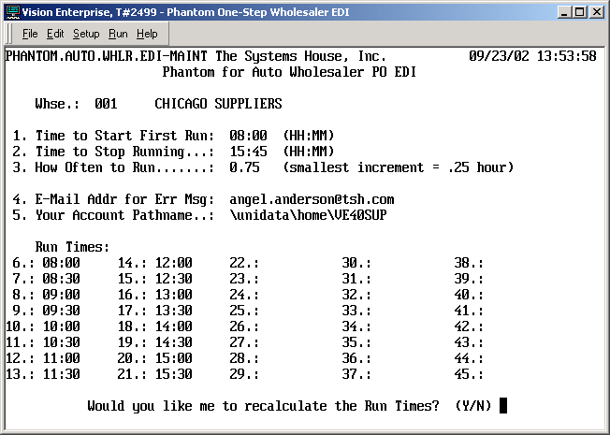

Following is an example of using the I# option:

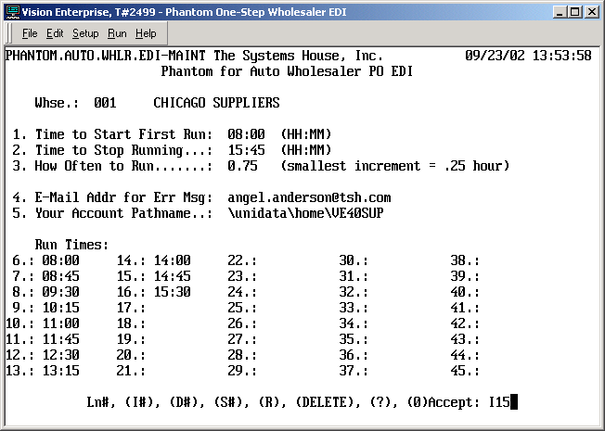

In this example, I’ve said that I want to insert a time in field 15. The current contents of all of the fields from 15 onward will be bumped down, then I’ll be put into field 15 so I can input the time that I want:

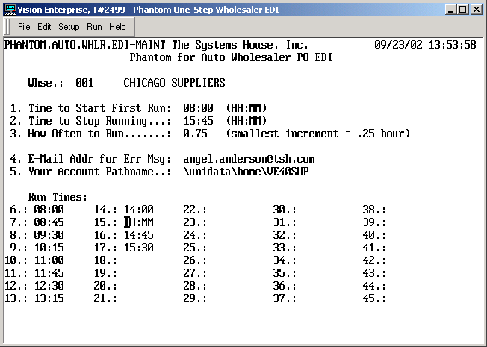

Please note: each warehouse has its own separate record, so the warehouses don’t have to run at the same time. It would probably be best if they do Not run at the same time, so that they aren’t competing for modem or pdm line access.
Starting One-Step Wholesaler EDI in Phantom Mode

Run menu selection 24-1-2-12-1:

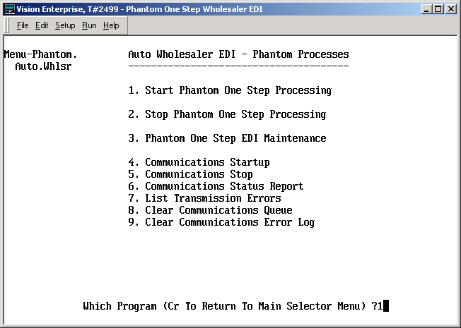

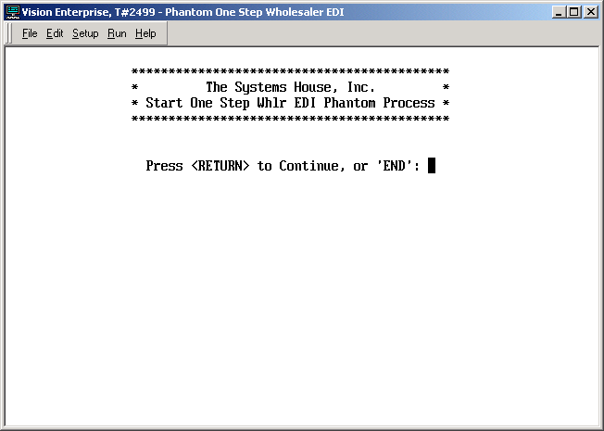

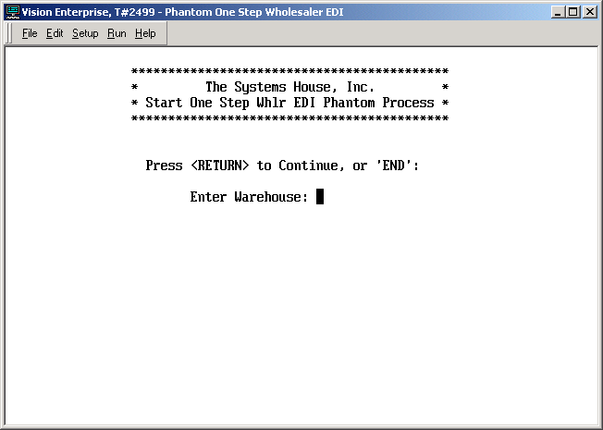

Enter Warehouse – END to exit. Input the warehouse that this start-up of phantom is to run for. The
warehouse id will be validated, and the warehouse name displayed.

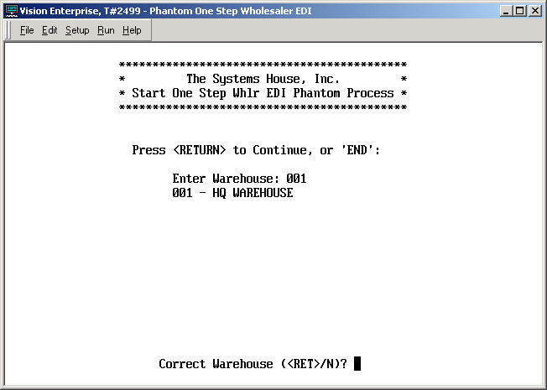

Correct Warehouse (<RET>/N)? - <Return> if this is correct. N to re-enter the Warehouse id.
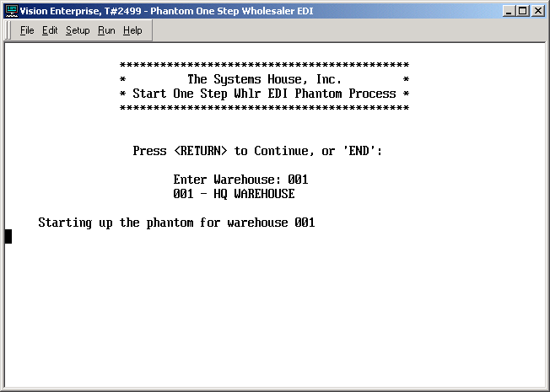

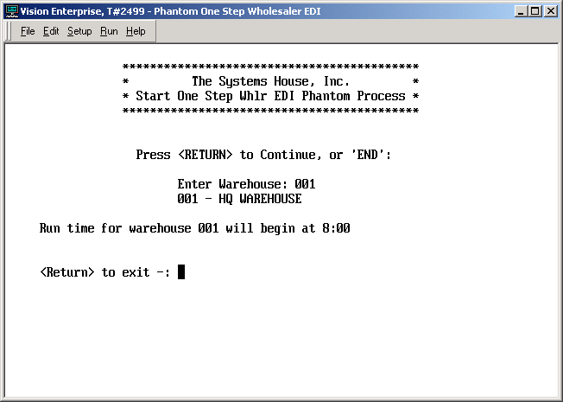

Above is the message that you will normally see if startup of the phantom is done before the first scheduled runtime in the parameter record.

Following are some of the other types of messages that you may receive:

Here is an example of the message you would see if you start the phantom processor after the first scheduled run time in its maintenance record:

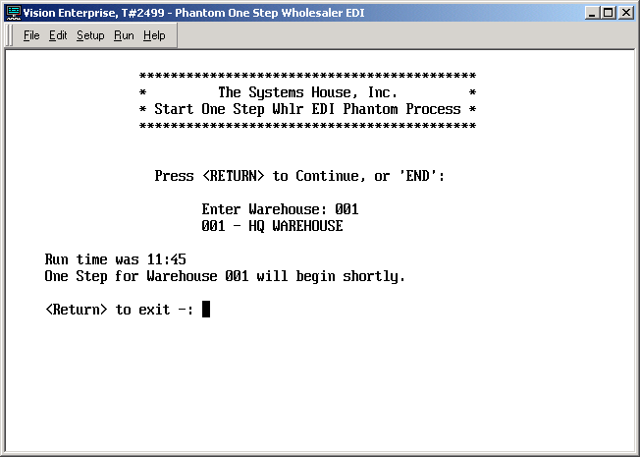

If you have started the phantom for this warehouse, and the initialization is still in progress, and you run the start-up again for the same warehouse, you will see this message:

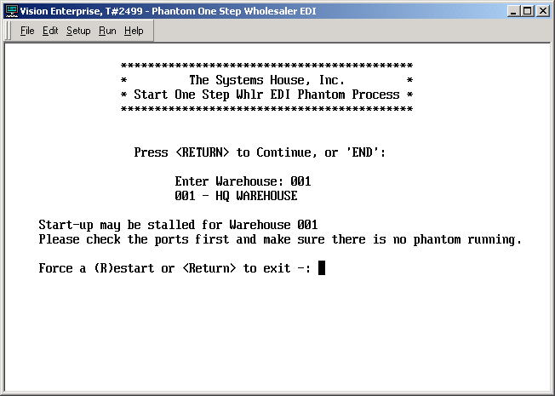

If you have already checked the ports, and there is none that is running PPHANTOM.AUTO.WHLSR-UPD, then there may be troubles with the phantom initialization process. If you want to prompt the system to try starting up the phantom again, input R.

Here is an example of a message you might see if there is already a phantom running for this Warehouse:

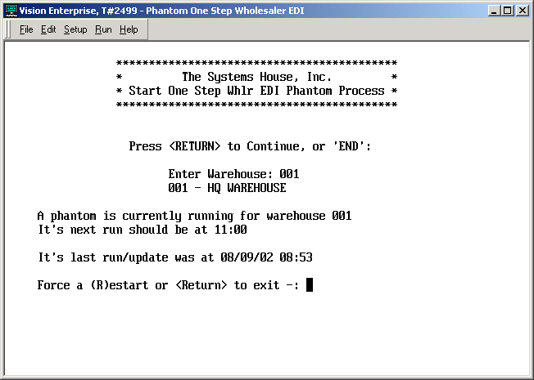

Force a (R)estart or <Return> to exit -: If you have been checking the users logged on, and have found that there is no one running PPHANTOM.AUTO.WHLSR-UPD, please check the _PH_ record for O_PHANTOM_ONE_STEPxxx (where xxx is the Warehouse id). Most errors should e-mail the error message(s) to the e-mail address that you provided in parameter maintenance before the phantom either continues or logs itself off. We try to prevent the phantom process from logging off, but some errors may be encountered that could cause it to happen.

After checking the Como record, if it appears that the phantom truly is logged off when it should not be, you can force a restart by inputting R. The existing Como record will be changed to O_PHANTOM_ONE_STEPxxx*yymmdd*hh:mm, so you don’t lose the report. Example: if it is currently 08/09/02, and the time is 11:15, then the name will be changed to O_PHANTOM_ONE_STEP001*020809*11:15. When the phantom starts running again, it will begin logging to a new O_PHANTOM_ONE_STEP001 record.

The program will then check to see which of the Run Times in the parameter record is closest to the current system time. If will display that time, start-up the phantom, and let you know that the phantom should begin running shortly. You may want to check the users logged on again, and check the Como record contents to make sure the phantom becomes active.

Example of e-mail error message from phantom wholesaler EDI

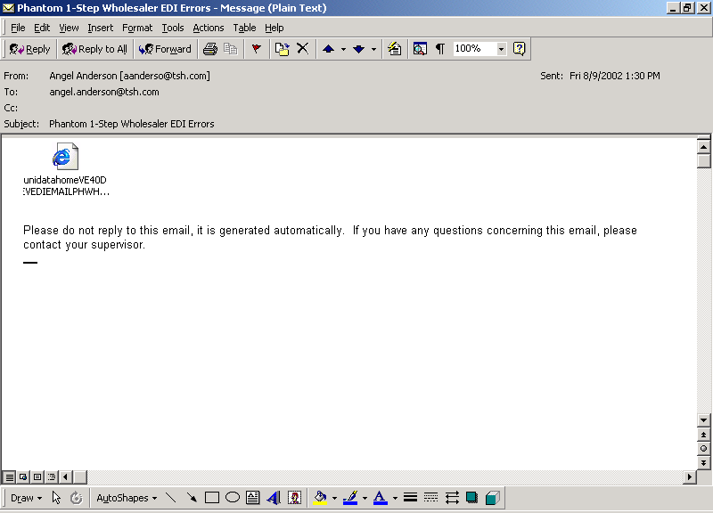

Double click on the included document.

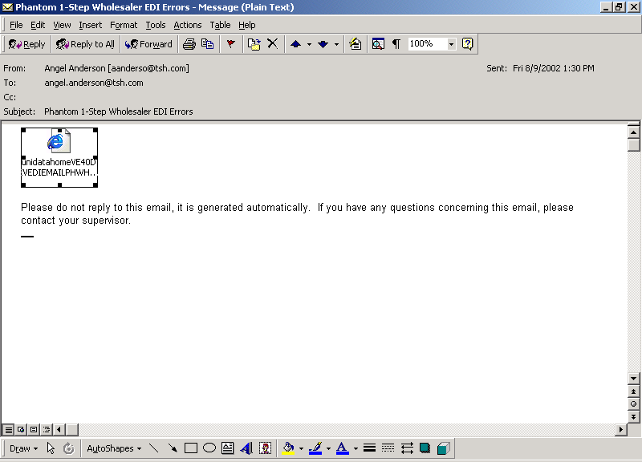

The e-mail default will go to “Save it to disk”. Select “Open it”:

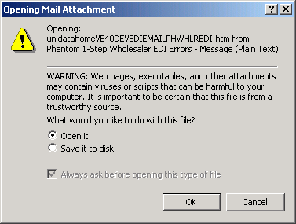

The errors report will open using Internet Explorer:

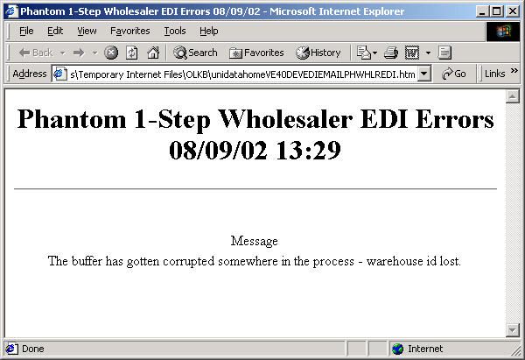

Forcing an early Stop of the Phantom One-Step

To force the Phantom One-Step Wholesaler EDI to stop before the last Run Time posted in its maintenance record, select menu 24-1-2-12-2:

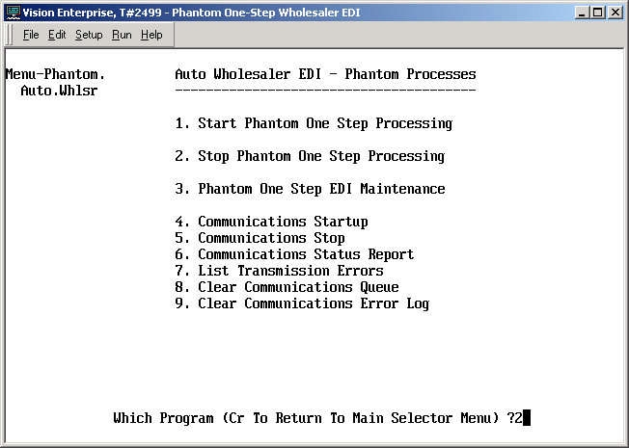

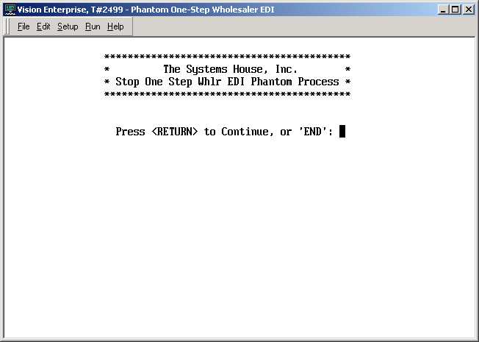

Input the warehouse(s) that you want to stop, or ALL to stop all of the phantoms that are running for One-Step Wholesaler EDI:

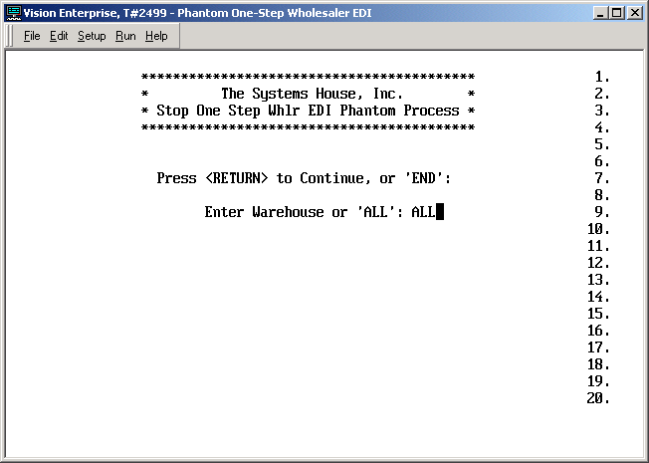

When you select ALL, every warehouse that has a phantom run record will be plugged with a STOP command. Then, the next time the phantom that is running for that warehouse checks its upcoming run time, it will “see” the STOP and log itself off.

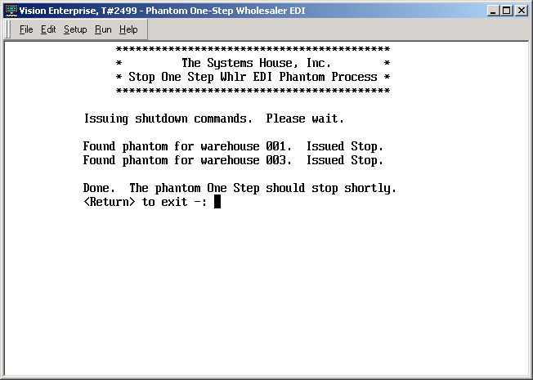

If you input specific Warehouses, the Stop will only be issued for those warehouses that you selected:

