Introduction

Customers using the Vendere interface will need to coordinate their Quarterly Wholesaler updates for E-Commerce with Thalerus in order to maximize update time and efficiency.

Customer Impact

A new item Menu-25.3.15 has been added to build and send the product information to Vendere for new or changed products from quarterly updates.

Once all Wholesaler updates have been completed the menu option 15 should be run. Prior scheduling will need to be made with Thalerus to determine when you will be running this.
The Quarterly Product Update Build for E-Commerce will create an item ‘qproduct’ for Vendere to pick up and load into their database.

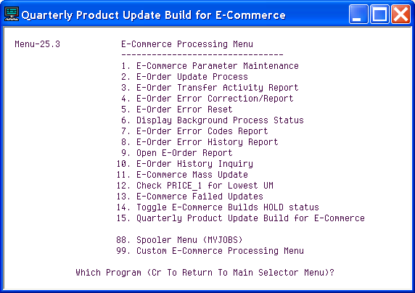

Press <RETURN> when ready to start the process. The number of items being sent will display and prompt you to hit return once the process has completed.
The ‘qproduct’ file will then be available for Vendere to pick up.

